Table 1: Correlation between climate belief index and variables used in the index
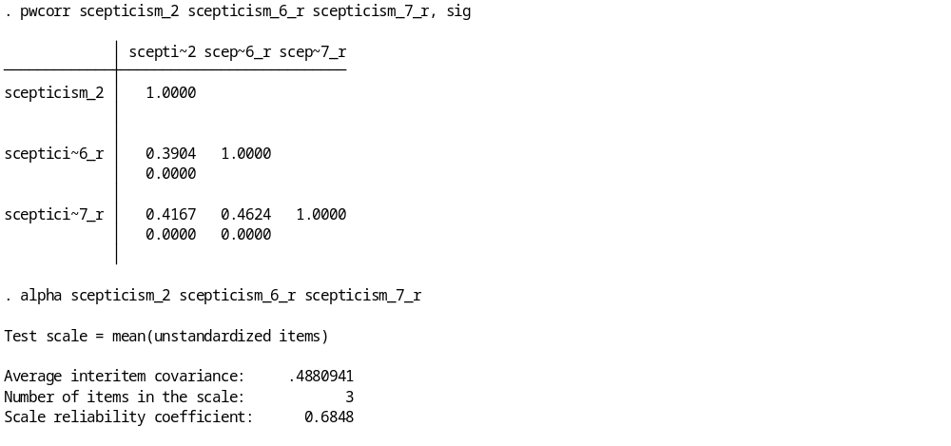
Table 2: Figure 1: Correlation between pro-government intervention index and variables used in the index
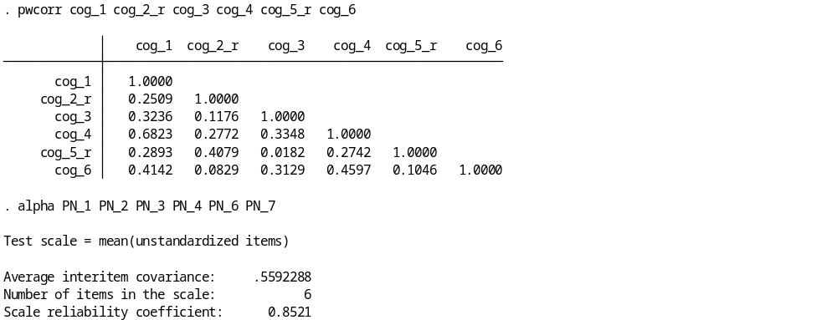

Table 3: Correlation between pro environment index and variables used in the index

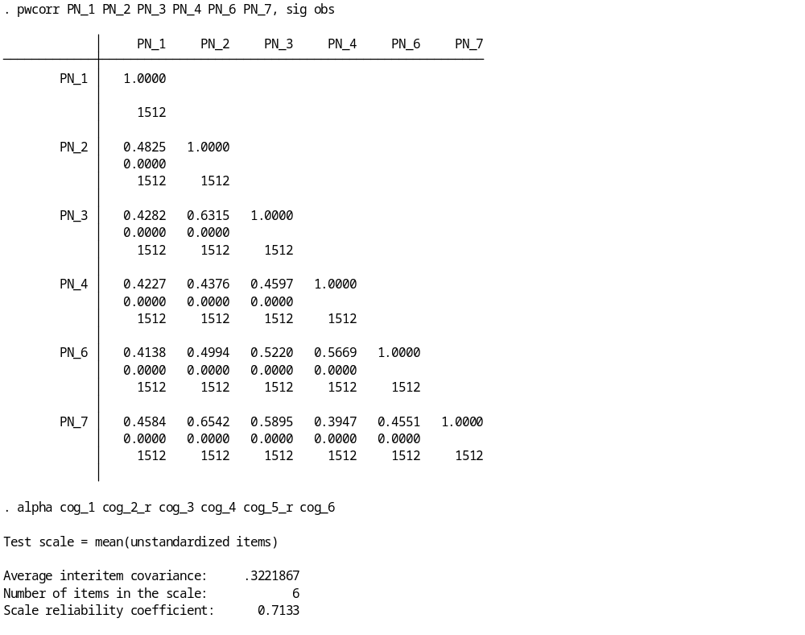
Table 4: Climate belief index test statistics
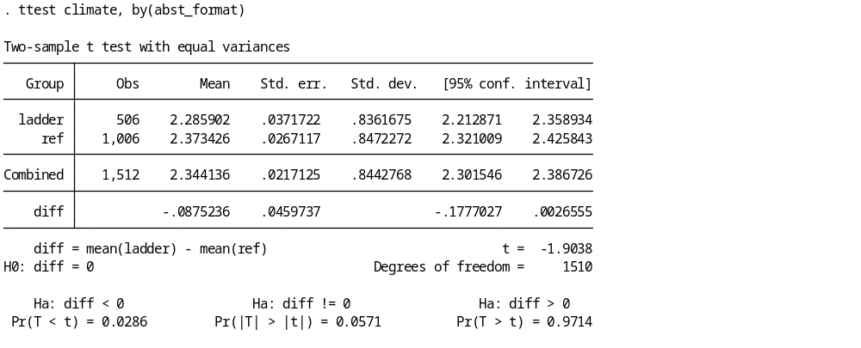
Table 5: Pro government intervention index test statistics
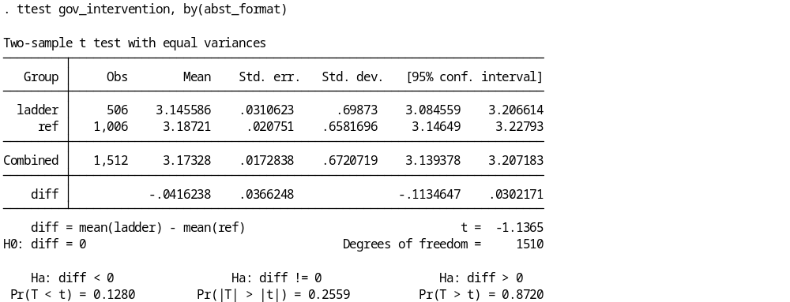
Table 6: Pro environment index test statistics
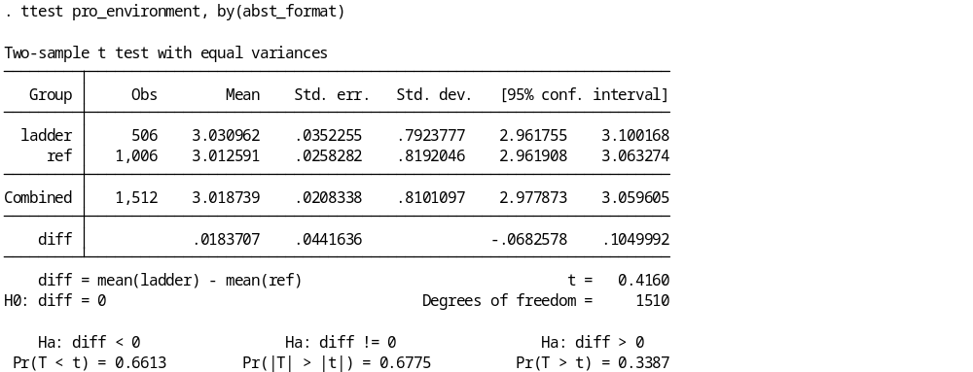

Table 7: Comparison of Attitudinal Measures Across Treatment Formats
Variable | Ladder | DC | Difference | p-value | Conclusion
Government intervention | 3.146 | 3.187 | −0.042 | 0.256 | No significant difference
Pro-environmental attitudes | 3.031 | 3.013 | +0.019 | 0.678 | No significant difference
Climate attitudes | 2.286 | 2.373 | −0.088 | 0.057 | Not significant at 5%; marginal at 10%
Note: p-values are from two-sample t-tests comparing the payment-ladder (TWPL) and dichotomous-choice (DC) groups.

Table 8: Dichotomous Choice (DC) Responses by Bid Amount
Costs (€) | Abstain | No | Yes | Total | Proportion No | Proportion Yes
48 | 12 | 21 | 32 | 65 | 0.5076923 | 0.4923077
72 | 11 | 30 | 40 | 81 | 0.5061728 | 0.4938272
84 | 12 | 24 | 45 | 81 | 0.4444444 | 0.5555556
108 | 7 | 35 | 31 | 73 | 0.5735342 | 0.4246575
156 | 13 | 31 | 40 | 84 | 0.5238096 | 0.4761905
192 | 11 | 25 | 25 | 61 | 0.5901639 | 0.4098361
252 | 9 | 32 | 28 | 69 | 0.5942029 | 0.4057971
324 | 16 | 41 | 27 | 84 | 0.6785714 | 0.3214286
432 | 11 | 35 | 29 | 75 | 0.6133333 | 0.3866667
540 | 9 | 31 | 22 | 62 | 0.6451613 | 0.3548387
720 | 12 | 39 | 13 | 64 | 0.7968750 | 0.2031250
960 | 14 | 28 | 15 | 57 | 0.7368421 | 0.2631579
1200 | 11 | 42 | 21 | 74 | 0.7162162 | 0.2837838
1440 | 19 | 42 | 15 | 76 | 0.8026316 | 0.1973684
Note: Proportion No and Proportion Yes are calculated using the total number of respondents at each cost level, so abstentions are included in the denominator.

Figure 1: Proportion of Respondents Voting “Yes” by Proposed Cost, Including and Excluding Abstentions
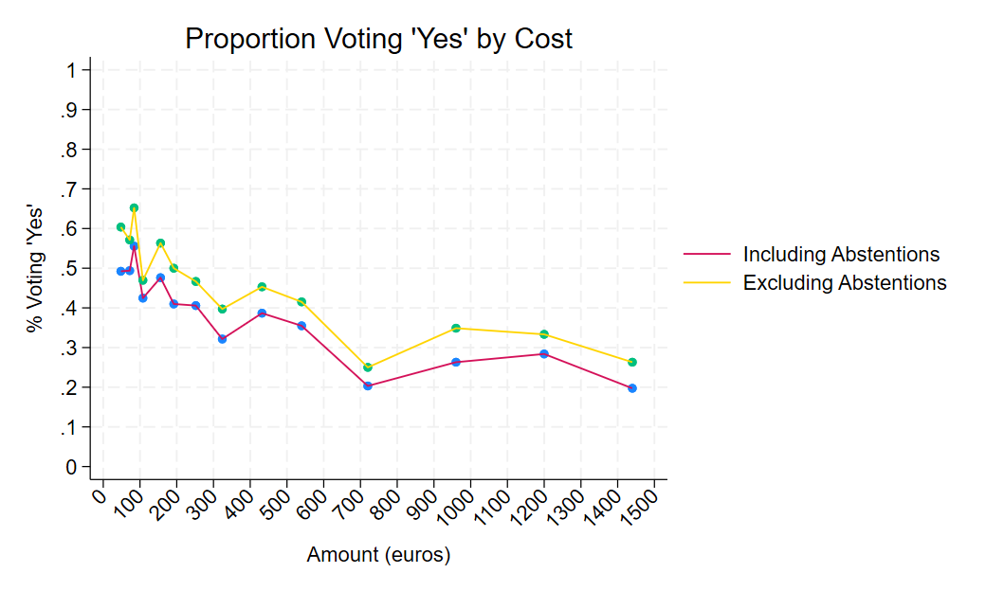Note: The “Including Abstentions” series calculates the proportion of “Yes” responses using all respondents, while the “Excluding Abstentions” series calculates the proportion among respondents who expressed either a “Yes” or “No” response.
Table 9: Descriptive statistics of willingness to pay by question format
Statistic | DC_WTP | TWPL_WTP
Observations (N) | 383 | 348
Mean | 348.188 | 268.5345
Standard deviation | 378.6489 | 287.7085
Variance | 143,375 | 82,776.16
Skewness | 1.612909 | 1.767491
Kurtosis | 4.550406 | 5.620861
Minimum | 48 | 48
1st percentile | 48 | 48
5th percentile | 48 | 60
10th percentile | 72 | 60
25th percentile | 84 | 78
Median (50th percentile) | 192 | 132
75th percentile | 432 | 333
90th percentile | 960 | 744
95th percentile | 1,200 | 840
99th percentile | 1,440 | 1,320
Maximum | 1,440 | 1,440
Notes: DC_WTP represented by cost and TWPL_WTP represented by average willingness to pay

Table 10: Paired t test of willingness to pay by question format
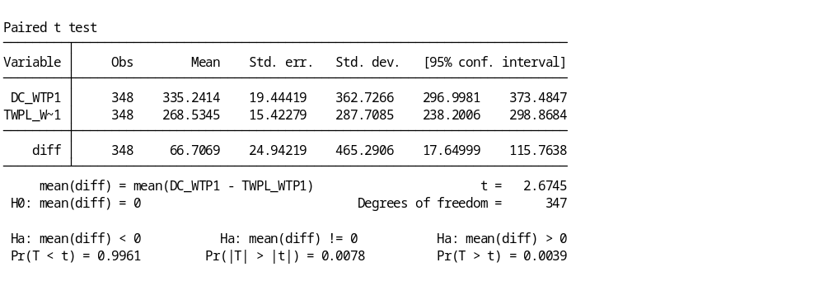
Willingness-to-Pay Analysis: DC and TWPL Methods
Table 11: Descriptive Statistics of Paired WTP Differences
Statistic | Value
Number of paired observations | 348
Mean | 66.71
Standard deviation | 465.29
Minimum | −1,356  −1,128
1st percentile | −1,356  −1,128
5th percentile | −696
10th percentile | −552
25th percentile (Q1) | −96
Median (Q2) | 24
75th percentile (Q3) | 264
90th percentile | 660
95th percentile | 1,020
99th percentile | 1,362
Maximum | 1,380
Skewness | 0.184
Kurtosis | 4.118
Note: Paired difference is defined as DC_WTP1 − TWPL_WTP1. Statistics are based on respondents with non-missing observations for both measures.

Table 12: Wilcoxon Signed-Rank Test Comparing DC and TWPL WTP
Statistic | Observations | Sum of ranks | Expected sum of ranks
Positive differences | 200 | 35,916.50 | 30,362.50
Negative differences | 147 | 24,808.50 | 30,362.50
Zero differences | 1 | 1.00 | 1.00
Total | 348 | 60,726.00 | 60,726.00

Test statistic | Value
Z-statistic | 2.957
P-value (two-sided) | 0.0031
Significance level | 1%
Decision | Reject the null hypothesis
Note: The Wilcoxon signed-rank test compares paired WTP measurements. The p-value of 0.0031 indicates a statistically significant difference at the 1% level. Positive differences indicate higher DC WTP than TWPL WTP, assuming the difference is defined as DC minus TWPL.

Figure 2: Histogram of Paired WTP Difference
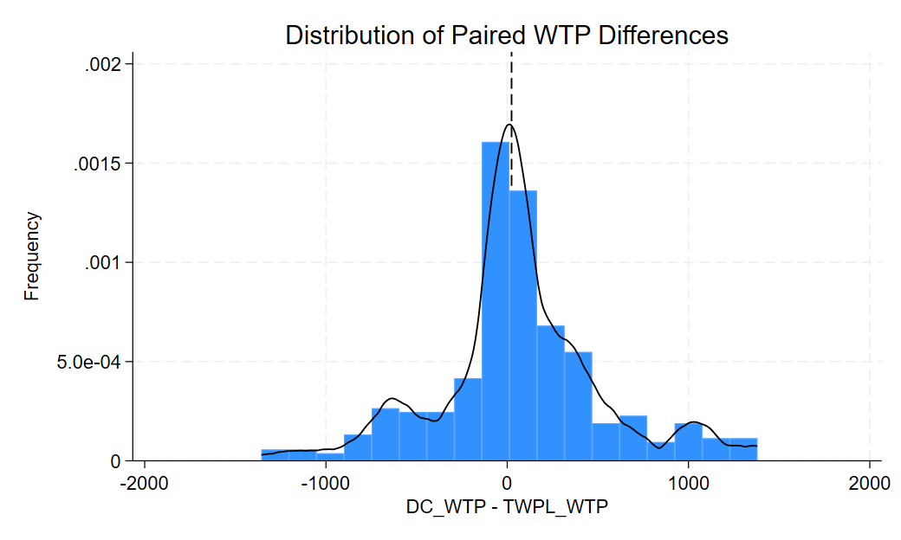
Figure 3: Boxplot of Paired WTP Difference
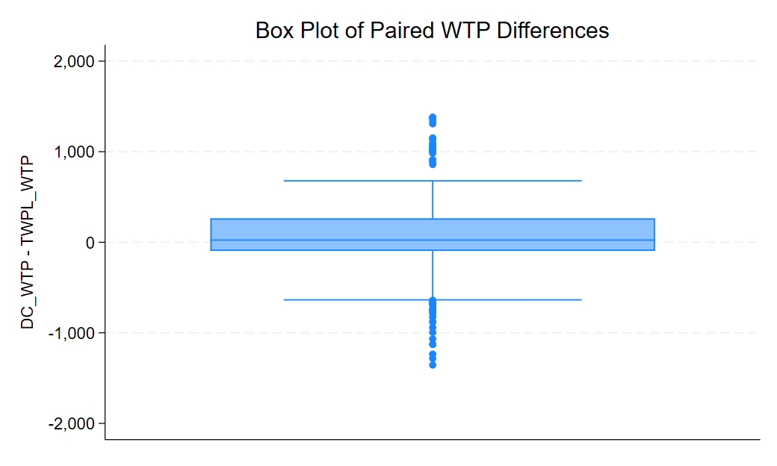

References
- https://www.oliverwyman.com/our-expertise/journals/energy-and-natural-resources-journal/2024/climate-fight-needs-a-20-trillion-investment-in-renewables.html
- Core Econs Project: https://books.core-econ.org/doing-economics/book/text/11-03.html#part-112-comparing-willingness-to-pay-across-methods-and-individual-characteristics

